Add Employee Testcase-UI

**Environment:** QA Test Challenge

**Platforms:** Desktop Browsers, Mobile Browsers and Native App.

**Preconditions:** User has the ability to add Employees in the Benefits Dashboard

**Products:** Benefits Administration Dashboard

**User Access:** Add, Edit and Delete an Employee

**Testing Challenge Testcases.**

**Scenario Add Employee:**

**1A. Add Employee Happy Path**

**Steps to test:**

1. Log in to Paylocity
2. Click the Add Employee button
3. Add the Employees first, last name and number of dependents
4. Click the add button
5. Verify expected results

**Expected results:**

1. The user sees First, Last Name and Dependent Text Boxes
2. Employee is added to the table seen in the Benefits dashboard with the correct information (first, last name and number of dependents are correct
3. Employee Salary, Gross Pay, Benefits cost Net Pay and Actions are correct.
   1. Employee Salary=52000
   2. Gross Pay= 2000
   3. Benefits Cost= 1,000+500 per dependent divided by 26 for number of pay periods.IE no dependents 1,000/26= $38.46 1 dependent is 500/26= $19.23
   4. Benefits cost minus Gross pay equal Net pay IE $2,000-$38.46= $1,961.54
   5. The Edit and Delete buttons will be seen in the last column of the table

**1B. Add Employee Cancel and Close**

**Steps to Test:**

1. Log in to Paylocity
2. Click the Add Employee button
3. Click the Cancel Button
4. Click the Add Employee button
5. Add data to all fields then click Cancel
6. Click the Add employee button
7. Add data to some of the fields
8. Click Cancel
9. Repeat steps 1-8 clicking the Close button

**Expected results:**

1. When the user clicks Cancel the worker will not be added to the Benefits Dashboard
2. When the user adds all data and clicks cancel the worker will not be added to the Benefits dashboard
3. When the user adds some data and clicks cancel the worker will not be added to the Benefits Dashboard
4. Like the Cancel button the employee will not be added when the button is clicked.
5. The add Employee window will close when the Cancel or Close button is clicked.
6. No data will be saved in the Add employee form after the Cancel or Close button is clicked.

**1C. Add Employee Text field verification**

**Steps to Test:**

1. Log in to Paylocity
2. Click the Add Employee button
3. Add a large amount of text to the First and Last name fields
4. Add a large number to the dependents field
5. Click Save
6. Repeat steps 1-5 With special characters in all fields

**Expected results:**

1. The dashboard should be able to handle a certain number of characters in the text boxes for First and Last Name depending on the Specs. for text boxes in the Benefits dashboard
2. The dashboard should handle larger text values gracefully ie: Not breaking the form
3. The First and Last name fields will accept 50 characters as a limit and the Dependents field will allow 32 characters

**Exploratory Testing:**

1. Validate the form is correct, the table fields as well as the windows that open.
2. Test navigating between views and see how it affects usability.
3. Let the session timeout and see how the application handles it.
4. Refresh the session and see how the application handles it.
5. Resize the window and see how the application handles the resize.
6. Make your browser lose connectivity and see how the application handles it.

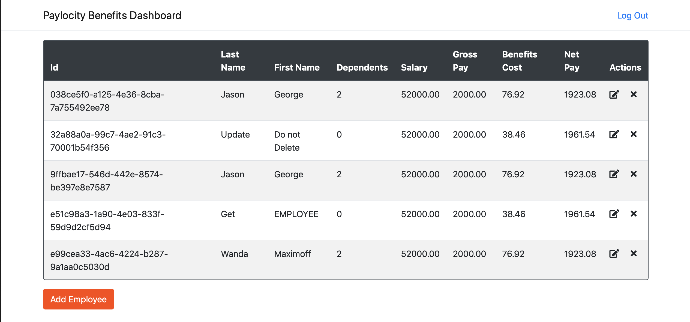

Dashboard screen

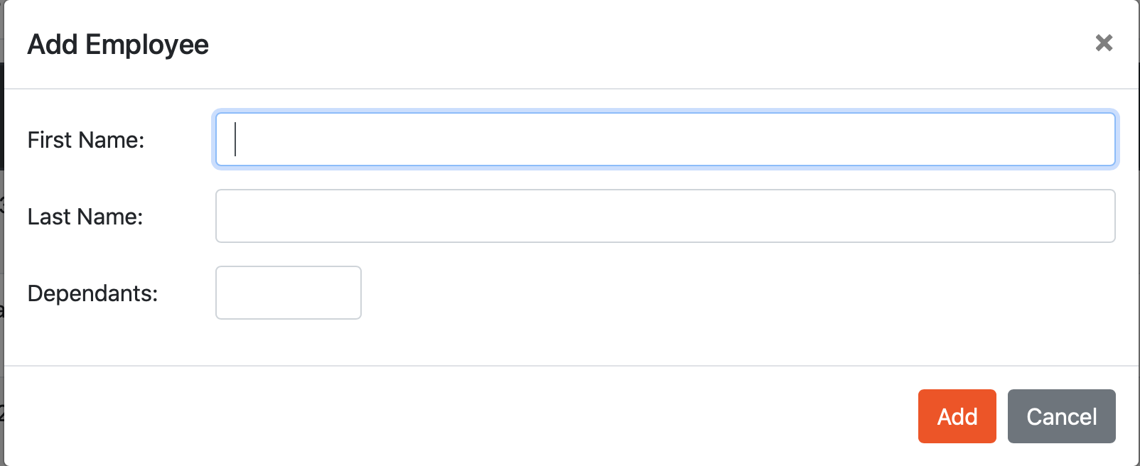

Add Employee screen